PreHeater Instructions

- Check fuel level. You can see the fuel level in the sight gauge on the side of the heater. Or by opening the blue screw-cap. Fill from the red, 2 gallon fuel jug in the storage shed marked (PRE HEATER). Do not allow the heater to run out of fuel. If fuel is low when you check it, please refill. NEVER USE GASOLINE or 100LL!!!
 | - Unplug the charging cable from the wall.
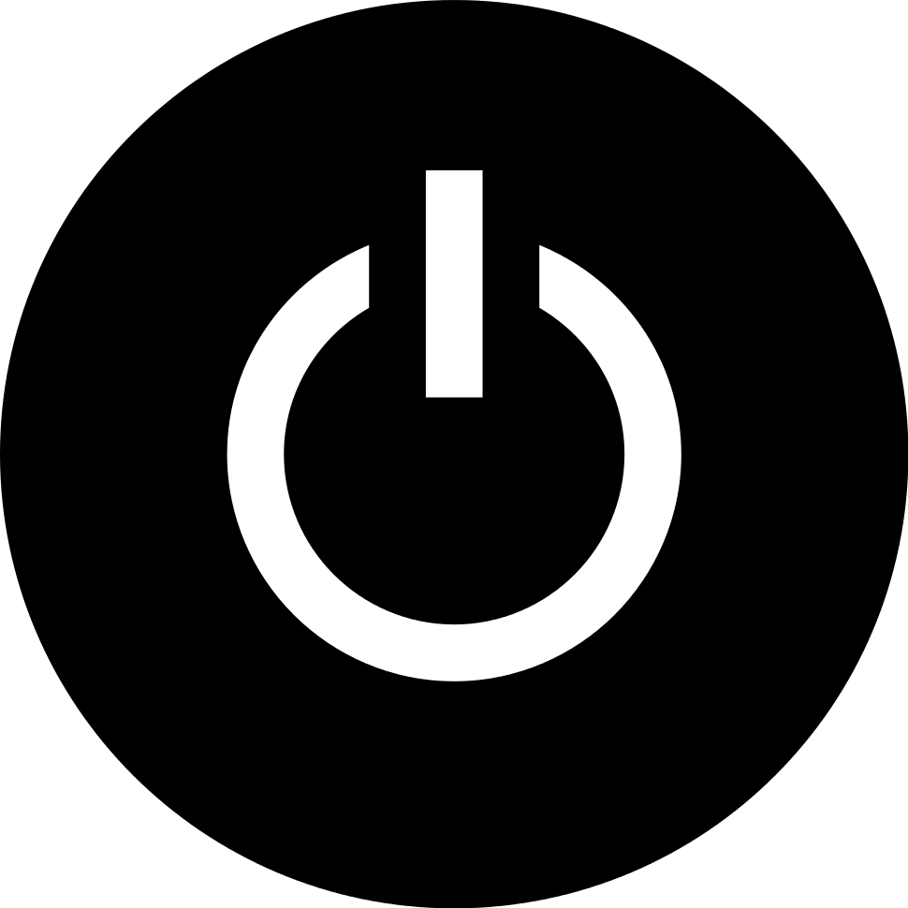 | - ON-Press the On/Off button on the controller firmly and quickly to turn the heater on and start the warmup process before even moving the heater to the airplane. The heater will slowly start and begin its warmup process. Do not expect to immediately feel heat or even hear the fan running yet. Complete startup will take several (4-5) minutes.
 | - Install heater hose/cowl plug in airplane (additional Mooney cowl plug inserts are available on the cart). Ensure that the heating process has begun while you perform airplane walkaround inspection.
 | - OFF-When you’re ready to end preheating (SEE NOTE), long-press the On/Off button for about 3 seconds. The heater will not immediately turn off but will rather, go through a shut-down procedure that gradually ramps down the heat, performs a cleaning burn and cools down before turning itself off. No other shutdown action on your part is necessary.
 | NOTE: If someone else is waiting for the heater on the ramp, do not turn the heater off. Give the running heater to the next person in line.
- Return the heater to the porch and plug in the charger.
- Please Replace the rain cover.

